Battles of the Great War

Lesson Focus: What did Canada contribute to the war effort on Europe? What was the result?

Canada’s Sacrifice: use the text or the power point information to complete this chart:

Battle | Interesting Details | Canada’s Role
2nd Battle of Ypres  p. # in text:  # on map:  when: | *first action seen by Canadian troops  *Germans used chlorine gas  *Other: | *____________ Canadian Casualties  * other:
Battle of the Somme  p. # in text:  # on map:  when: | *Commander: Douglas Haig  *Over 1 million casualties overall  *called the “bloodbath”  *No clear victory; only 11km gained  *other: | *___________Canadian Casualties  *85% of Royal Newfoundland regiment suffered casualties from German machine guns  *other:
Battle of the Vimy Ridge  p. # in text:  # on map:  when: | *Germans had captured the ridge in their initial attack (strategic location)  *over 3500 men killed, 7000 wounded  *largest victory of the war up to that date  *efficient planning and training contributed to victory  *other: | *_____________ Canadian lives lost  * other:
Passchendaele (3rd Battle of Ypres)  p. # in text:  # on map:  when: | *mud was so bad that horses and men drowned in it  *poorly organized but Allies still won  *nearly ½ million soldiers lost on both sides  *other: | *______________Canadian live lost  *other:

Map:
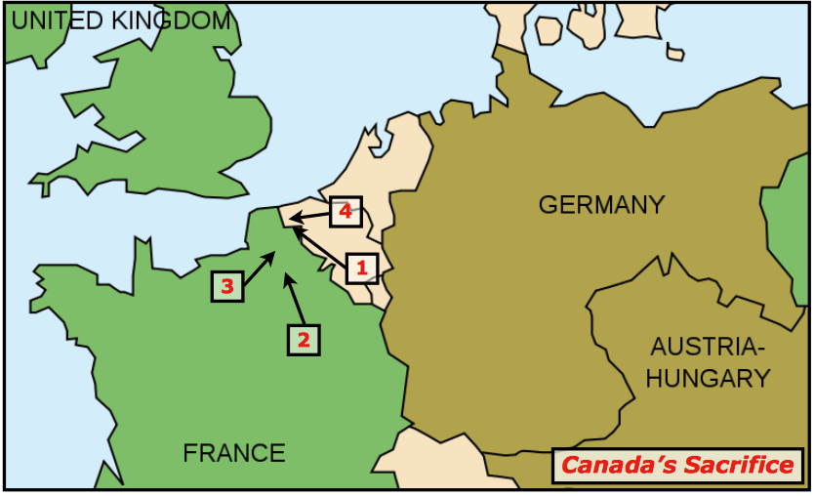

What else do you need to know to understand how the war played out in Europe? Read some more in your textbook to make notes on:

War in the Air (p. 34):

War at Sea (p. 35):

Leaders of the various main countries involved in the war:

Other important names (eg. Sam Hughes)

Define the following terms:

- Casualties:

- Reconnaissance:

- Ace:

- Merchant Marine:

- Convoy:

