End of WWI – Aftermath of the Great War

Lesson Focus:
What effect did Canada’s participation in WWI have on Canadian society and its status as a nation?
How did WWI end, and what agreements followed?

Provide a brief definition and/or example for the following terms and ideas:

- armistice
- Treaty of Versailles
- Pandemic

Questions:

- Why did Czar Nicholas abdicate?

- Why did the USA enter the war?

- What was the Hundred Days Campaign. What was Canada’s role?

- Describe briefly the collapse of the Central Powers and the armistice that ended hostilities.

- Which of the terms of the Treaty of Versailles do you think would have upset Germany the most? Why?

- Look at the map below, which nations were changed the most as a result of WWI?
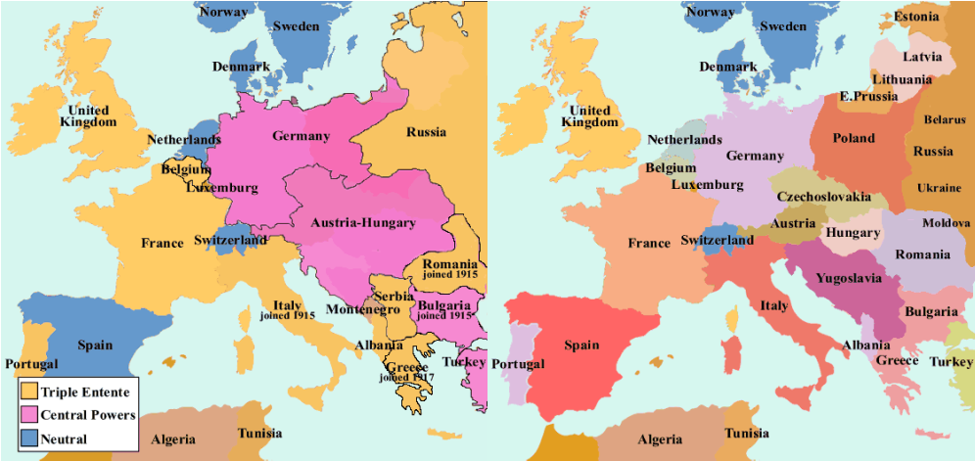

- Complete a +/- /interesting chart for the League of Nations (benefits, drawbacks, other ideas that occur to you).

Benefits (+) | Drawbacks (-) | Interesting (other ideas)

