Environment and Sustainability

Examine the below source(1). What process is being described? Where in Canada does this take place? What other steps or consequences could be associated or added to this diagram?

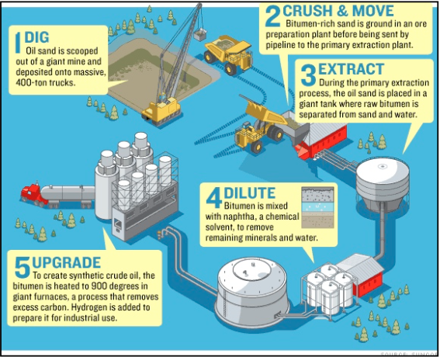

Examine the Source below(2). What sustainability issue do you think is being addressed by this photo? What relationship does this photo have with source 1 (how does it fit with the diagram)? Include another image or graphic that could also fit with this sustainability issue.

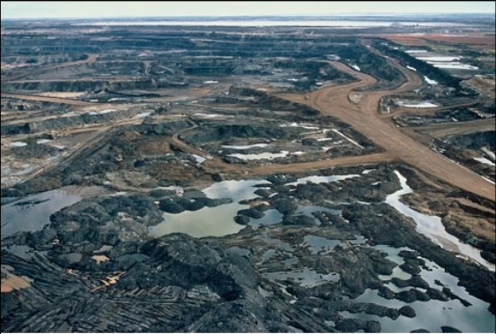

Define the following with an example if possible:
- groundwater
- wastewater
- aquifer
- carbon footprint

- Do you agree that increasing populations are the main threat to the world’s freshwater supply? Explain.
- What are the main threats to surface water in Canada? What is the main use of water by humans?
- Complete the following chart on the use of groundwater:
Benefits | Problems

- Should Canada treat water as a resource to be traded?
- Compare Ozone Depletion and Global Warming:
Problem | Ozone Depletion | Global Warming
Definition/Causes
Gases Responsible
Effects or impacts (particularly Canada)
Agreements or protocols (include how successful they were)
Solutions to Problem
Any Advantages?
Other comments/interesting facts

