3 Functions of Stage Lighting
______________________– the audience has to be able to see the onstage action
_____________________ - bright vs. dim lighting; colors represent mood
_____________________– lighting should accurately reproduce obvious light sources; sun, moon, lamps, fireplace, etc.
Basic Lighting Equipment
___________________ (also called a ____________) – throws strong, focused light from a long distance
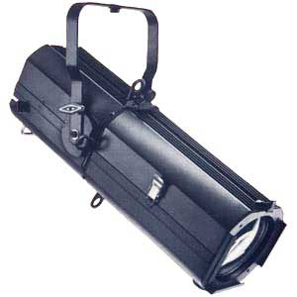

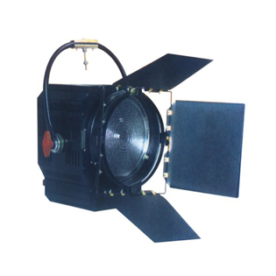
________________ – throws softer light on larger area from a shorter distance

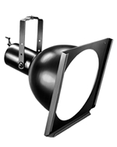
____________________- lights large areas in strong light

__________– bright, well focused lighting
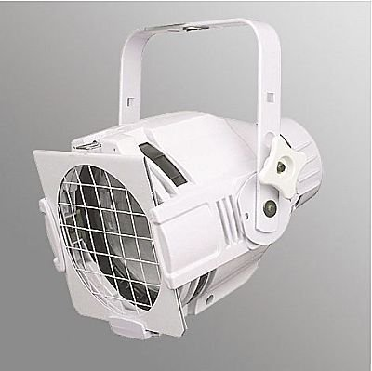

___________________ – throws bright focused light on a moving actor
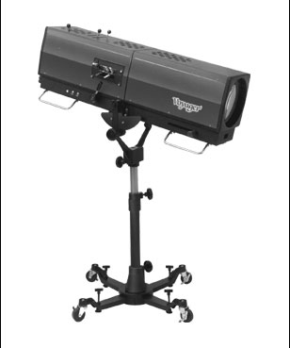

_____________________________________ – washes light over a large area
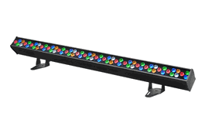
___________________________________ – the unit that controls the operation of lights
____________________________________ – color filters for creating colored light
___________________ – metal disks with cutouts for creating patterns or light
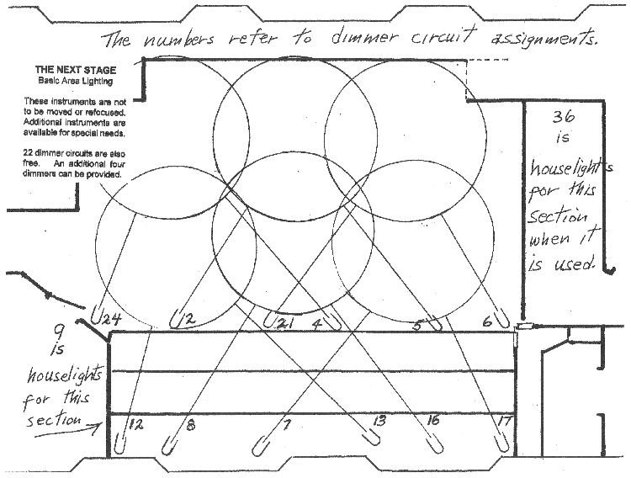 _______________________________
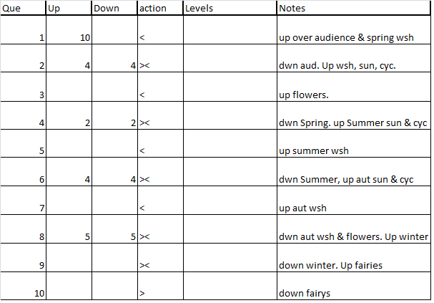 _____________________________________

5 Basic Types of Lighting:

